Accessing ESR Self-Service – Employee Guide

Quick Links
Accessing ESR for the first time
Password Retrieval / Reset Troubleshooting!
Create / Update Password Screen
Password Rules
Creating Your Password
Viewing Payslips and P60s
Important Information – When Leaving the Trust
Contact for Support and Information

Accessing ESR for the first time
Use these instructions to access ESR Self Service either for first time or if you have not accessed ESR Employee Self Service in over 6 months. To set up your account you must have a Trust or NHS.net email address, and have access to that email account during the set-up process.
The ESR login page can be accessed through the ESR Hub: https://my.esr.nhs.uk/

- Click on https://my.esr.nhs.uk/ to open the ESR Hub, then at the top right of the screen click on ‘Login to ESR’:
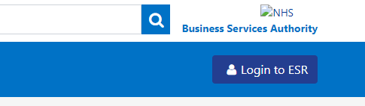
- Click ‘Forgotten | Request Username/Password | Unlock Account’:
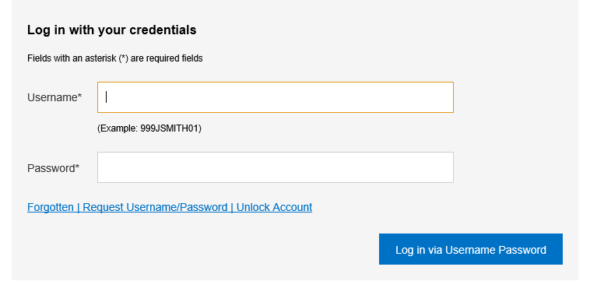
- Enter your Trust email address (@uhb.nhs.uk, @heartofengland.nhs.uk or @nhs.net) along with your date of birth and click ‘Submit’:
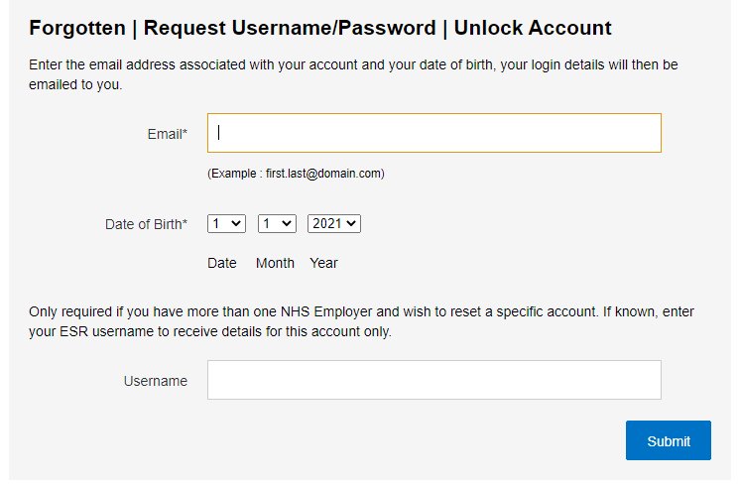
- You will receive an email from PROD Workflow Mailer <esr.wfmPROD@nhs.net> similar to the email below, this can typically take 10-15 minutes to arrive:
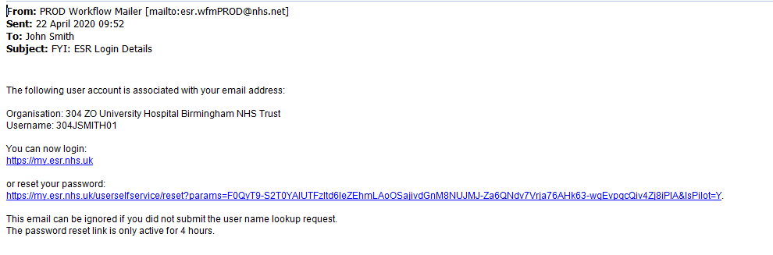
Your username will begin with either 304 or 295
- click the “reset your password” link in the email:
This will take you to the Update Password screen.

Password Retrieval / Reset Troubleshooting!

- If your ESR account is linked to a different organisation or @nhs.net account and you are unable to access the email from a Trust PC you will need to contact the system administration team
- Once you receive the email you only have 4 hours to click on the link to retrieve or reset your password. If more than 4 hours have passed, you will need to go back to the ‘Forgotten | Request Username/Password | Unlock Account’ page and go through the process again.

Create / Update Password Screen
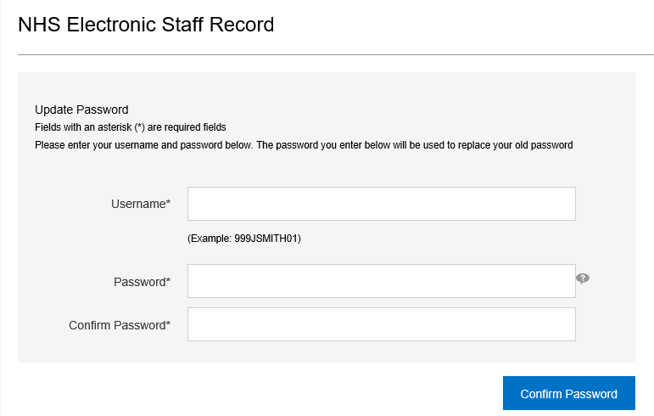
Enter the username you received in the email e.g. 304JSMITH01 / 295JSMITH01 and create your password using the rules below.

Password Rules

  - Your password must be 12 or more characters in length
  - Your password must not:

  - be the same as any of your previous 4 passwords
  - include words and terms associated with ESR, your role, name, locality or other place names

Creating Your Password
- Type a password in the Password field
- Retype the same password in the Confirm Password field
- When the eye button appears you can click and hold it to check what you have typed and ensure there are no mistakes:
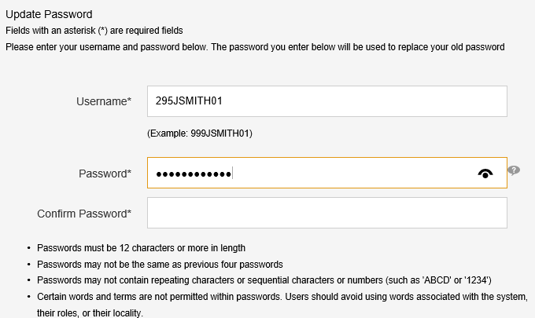
- Click on the Confirm Password button:
- If your password does not meet the requirements, it will not be confirmed and you will see a red alert explaining why; e.g.:
- ESR permits a few attempts to create a password that meets its requirements. If you exceed this, you will need to return to the ‘Forgotten | Request Username/Password | Unlock Account’ page and submit another password request:
- Once you have successfully updated your password you should be taken to the ESR home screen. If you see the ESR Hub or login screen instead, just re-enter your username and new password.

Viewing Payslips and P60s
- After you log in to ESR, payslips and P60s can be downloaded from the ‘My Payslip and P60’ box at the top right of the ESR homepage:
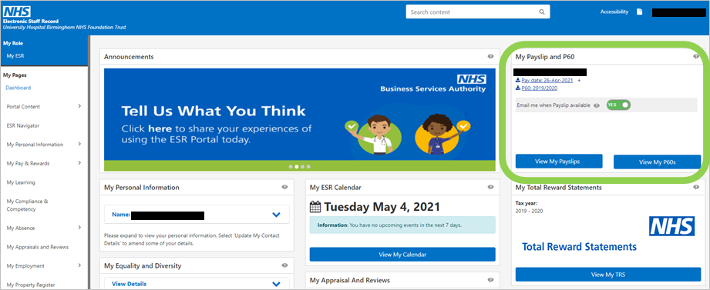
- To view your latest payslip or P60 for your primary assignment, click on the links within the box:
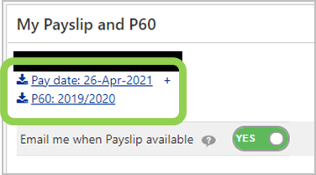
- To see one of your previous three payslips click on the ‘+’ next to your most recent one, and they will appear in a list:
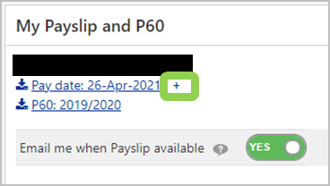 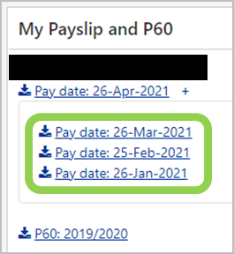
- To view older payslips or those from other assignments, e.g. if you have a Bank contract, click on the ‘View My Payslips’ button:
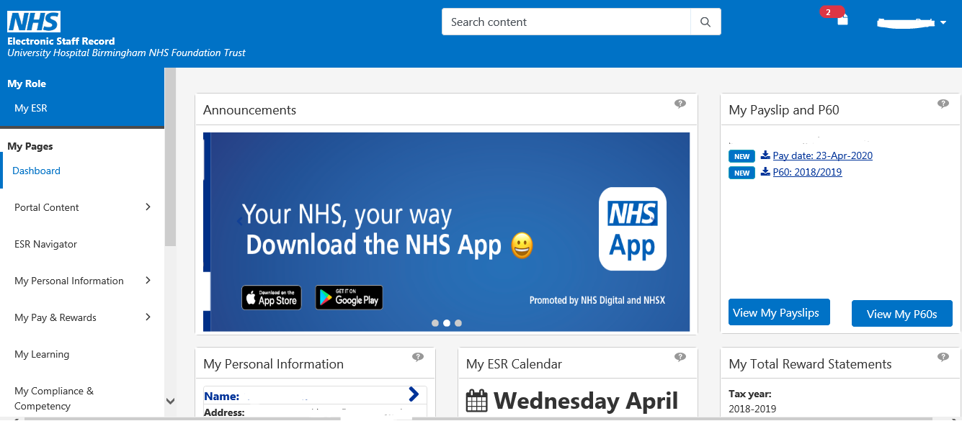
- By default the search page will show your primary assignment number, the current year, and your most recent payslip
- If you want to see payslips for any other assignment, year, or month, select them from the drop down menus:
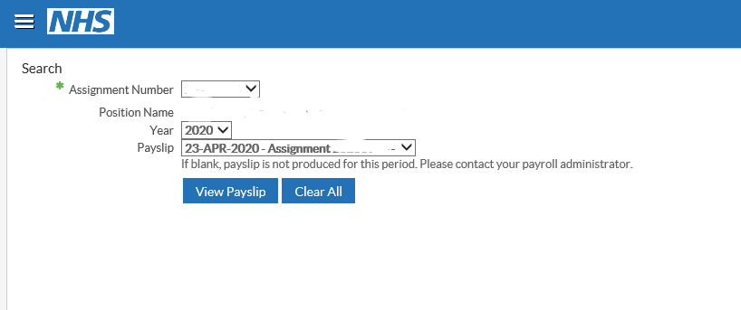
- Click on ‘View Payslip’ and it will be downloaded in a PDF format.
- Depending on which internet browser you are using, you should see a ‘downloads’ message appear at the top right or bottom left of the screen; click on it to view your payslip.
When using a shared PC, please ensure that you do not save a copy of your payslip or P60 to the PC; otherwise it will be accessible to others.

Important Information – When Leaving the Trust
When you leave the Trust, you will no longer have online access to your previous payslips or P60s. Any payslips and P60s should be downloaded / saved as a PDF file and / or printed out prior to your last day of service.

Contact for Support and Information
If you experience any difficulties registering with / accessing ESR or using any of the functionalities described here, please contact the ESR system administration via email to DataManagement@uhb.nhs.uk

Please ensure you email from a Trust email account if you have one, to ensure that correspondence with you is secure.
Please do not contact the IT Service Desk unless you have been specifically advised to do so by the ESR ServiceDesk.

Accessing Your Payslip from Home

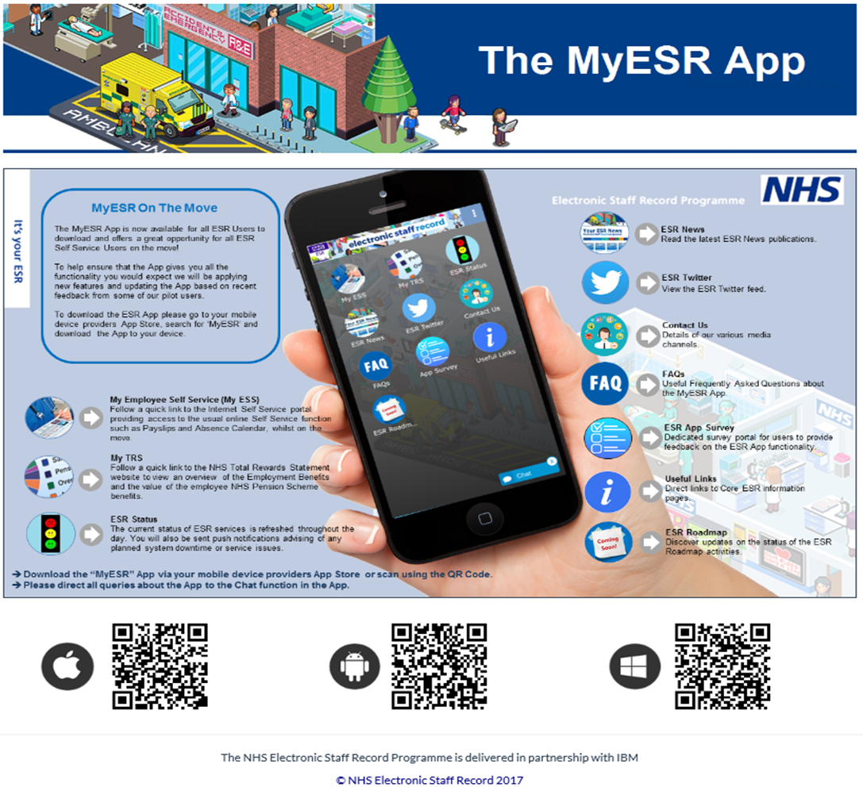
Once you have retrieved your username and re-set your password (refer to Accessing ESR Self Service – Employee Guide) you can also download the ESR App to use on your mobile device. Go to your device provider’s App Store, search for ‘MyESR’ and download the App to your device.

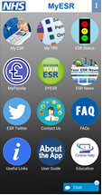

Once in the app it will re-direct you to the mobile version of the website.
All payslips are available through the My Payslip button where you will be required to enter your ESR Employee Self-Service username and password in order to gain access.

